CARD 0

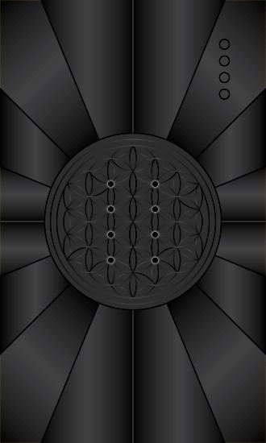
For this card, I wanted to convey the hidden, unseen aspect of this stage of the creative process. AMEN means that which is hidden or concealed. At this stage, we have Consciousness, which is passive. Consciousness is that which perceives. The active side of Consciousness is the act of willing. It is Consciousness that creates. The other half of the equation is Energy/Matter. At this stage, energy is at rest and matter is unformed. So the color conveyed in this image is black to represent that consciousness is imperceptible, hidden, and also that there are no discernable shapes, forms to be seen as energy is at rest. Consciousness has not yet willed energy into motion.

The flower of life pattern lies at the background. In the new physics, we learn that this pattern lays at the foundation of empty space. It cannot be seen, but it is there. It is said to be the basic template for everything in existence; all geometric forms can be found within it, including sacred geometry shapes like the Platonic Solids, Metatron’s Cube, and the Merkaba. The Flower of Life symbolizes creation and reminds us of the unity of everything: everything that is created comes out of the same blueprint.

On the lattice of the flower of life is the odu for Oyeku. Oyeku is darkness, the complete contraction of matter into what physics calls a black hole. In human terms this can mean physical death, and thus, it reinforces the idea that energy is at rest at this stage. The Yoruba word for black is dudu and is associated with Oyeku as a symbol for the invisible dimension, the source of creation.

Oyeku also refers to the end of cycle. When a baby is born there is an end of cycle of living in the womb. Similar to that, it is the end of energy being at rest. In the subsequent stage creation begins. Oyeku as the end of a cycle can bring a blessing of peace. It can also represent a premature ending of a cycle (things coming to rest) that may not result in full maturity or benefit.

